Energy Analysis of Geothermal Resources in the Volcanic Zone of North Sumatra for Renewable and Reliable Power Supply
Roy Lamrun Sianturi¹*, Hendrik V. Sihombing², Janter Simanjuntak³, Farel Napitupulu⁴
^{1*,3} Departement Mechanical Engineering, Universitas Negeri Medan, Indonesia
^{2,4} Departement Mechanical Engineering, Universitas Sumatera utara, Indonesia
Coresponding Autor: roylamrun@unimed.ac.id

Article history  Received Date:  21 September 2025;  Accepted:  16 October 2025;  Published:  24 October 2025 | Abstract  Geothermal resources represent a vital component in Indonesia’s transition toward sustainable energy, particularly in volcanic regions such as the Sibayak field, North Sumatra. This study aims to evaluate the geothermal potential through integrated reservoir characterization, decline curve analysis, and Life Cycle Assessment (LCA). Field data from three exploration wells were analyzed, including temperature, pressure, enthalpy, and estimated capacity. Decline curve modeling was performed to assess production sustainability under scenarios with and without reinjection. Furthermore, LCA was applied to compare the environmental footprint of geothermal power with coal and natural gas. Results indicate reservoir temperatures ranging from 230–245 °C with enthalpy values exceeding 1,000 kJ/kg, supporting an estimated capacity of 50–55 MWe. Reinjection was shown to reduce annual production decline from ~5% to ~2%, thereby extending reservoir lifetime. LCA outcomes confirmed geothermal energy’s superior environmental performance, with CO₂ emissions as low as 90 g/kWh compared to coal (>1,000 g/kWh) and natural gas (~450 g/kWh). These findings emphasize the strategic role of Sibayak geothermal development in strengthening Indonesia’s clean energy portfolio while ensuring long-term resource sustainability.
Keywords: Geothermal energy; Sibayak field; Reservoir characterization; Decline curve analysis; Life Cycle Assessment (LCA); Renewable energy transition; North Sumatra
© 2025 Penerbit Giovani publisher. All rights reserved

Introduction
The volcanic arc in Sumatra hosts numerous high-enthalpy geothermal systems, rendering North Sumatra one of the most promising regions in Indonesia for harnessing renewable, reliable baseload power. As the nation aims to decarbonize its energy mix and fulfill increasing electricity demands—especially in rural and highland areas—geothermal energy offers a low-emissions, stable alternative to fossil fuels. However, several critical technical, economic, and policy-oriented barriers still limit the full exploitation of geothermal resources. Accurate estimation of extractable energy, reservoir behavior under production, and infrastructural constraints remain under-addressed, especially at the local reservoir scale in volcanic systems. Recent studies underscore the necessity for detailed reservoir modeling and up-to-date subsurface data to inform both investors and policymakers in North Sumatra and similar volcanic zones [1], origin studies of high heat flow in the Sumatran back-arc basins point to spatially variable thermal regimes that must be understood for reliable power generation [2].
In North Sumatra, several field investigations between 2020 and 2025 provide more detailed empirical data that help bridge the gap between theoretical potential and
realizable power. “Updating Numerical Simulation Model of Sibayak Field” (Firanda et al., 2024) offers new temperature‐pressure measurements from wells SBY-01, SBY-02, SBY-09, SBY-10, demonstrating that earlier conceptual models underestimated influence of recharge through caldera faults and outflow towards the southeast of Sibayak.[3],[4] A geometric modeling effort (“Comprehensive Geometric Modeling of the Sibayak Geothermal Field”, Qarinur et al., 2024) using borehole data has delineated reservoir boundaries and identified zones with high potential, aiding in planning future well placements. [5] In another study, integrated geochemical and geophysical surveys in Siogung-Ogung hot spring area (North Sumatra) employed resistivity and magnetic methods alongside geothermometry to estimate reservoir temperature > 250-300 °C, indicating strong prospects for electricity generation if proper subsurface infrastructure is established. [6] Meanwhile, a preliminary resource assessment of Seulawah Agam employs Monte Carlo economic simulation to understand which incentive mechanisms might improve financial feasibility for 150-300 MW capacity plans under public-private partnership structures.[7]
Despite these advances, substantive research gaps remain: (i) many local reservoirs lack long-term history of production or pressure/temperature decline data, necessary for calibrating time-dependent numerical reservoir models; (ii) heterogeneity in rock thermal conductivity, clay cap thickness, and permeability/fault structure (especially near upflow and outflow zones) are not well quantified across all fields in the region; (iii) few studies couple detailed reservoir-scale simulations with grid integration reliability assessments and stakeholder cost/risk analyses, so that the potential supply reliability is not well benchmarked; (iv) policy and regulatory uncertainty, including licensing, environmental constraints, and financing risk, further limit investor confidence and delay deployment. These gaps reduce the ability to reliably forecast output, determine optimal well-locations, or design reinjection strategies to maintain long-term performance.
To address these limitations, this research aims to (a) quantify the extractable geothermal energy for several volcanic geothermal systems in North Sumatra using updated well, geophysical, and geochemical data collected from 2020 to 2025; (b) develop and calibrate numerical reservoir models (including natural-state and production-scenario simulations) to capture heterogeneity (temperature, permeability, conductivity, recharge/outflow zones); (c) evaluate the reliability of power supply under dynamic operational conditions (e.g. temperature decline, injection strategies, recharge variability); and (d) provide technical, economic, and policy recommendations to optimize development, including well-site selection, mitigation of thermal and pressure decline, financing/incentive mechanisms, and regulatory frameworks. The anticipated contributions of this study include: refined reservoir models for Sibayak, Seulawah Agam, and selected emerging prospects; updated estimates of realisable installed capacity; insights into supply reliability under realistic constraints; and strategic guidance for stakeholders to accelerate geothermal deployment in volcanic zones.
In sum, by integrating recent local field data with rigorous numerical modeling and reliability analysis, this research seeks to narrow the gap between potential and realization for geothermal resources in North Sumatra. Such efforts are essential not only for advancing Indonesia’s renewable energy goals but also for offering a template for similar volcanic geothermal frontier regions globally.

Materials and Methods

Study Area
This study focuses on geothermal systems located within the volcanic arc of North
Sumatra, Indonesia, specifically the Sibayak, Seulawah Agam, and emerging Siogung-Ogung prospects. These fields were selected due to their high enthalpy potential, availability of recent well data, and representation of the hydrothermal characteristics typical of Sumatra’s volcanic geothermal zones. Sibayak is among the earliest developed fields in Indonesia and has been the subject of several reservoir simulation studies [8], [9]. The field lies within a Quaternary volcanic complex with fractured andesitic and dacitic formations, which host geothermal reservoirs at depths of 1,200–2,500 m. Seulawah Agam, on the other hand, remains under early development, with feasibility and incentive studies recently undertaken [10]. The Siogung-Ogung system was investigated more recently using integrated geophysical and geochemical methods, revealing reservoir temperatures >250 °C [11].

Data Sources
The data set integrates primary and secondary sources collected from 2020 to 2025:
- Well Data – Temperature-pressure logs, enthalpy estimates, and injection test results from Sibayak wells (SBY-01, SBY-02, SBY-09, SBY-10) and exploration boreholes in Seulawah Agam.
- Geophysical Surveys – Magnetotelluric, resistivity, and gravity surveys were employed to delineate reservoir boundaries, fault structures, and cap rock thickness [9];
- Geochemical Data – Stable isotope ratios (δ18O, δD), major ion chemistry, and silica geothermometry analyses were used to determine reservoir fluid origins, recharge zones, and equilibrium temperatures.
- Secondary Sources – Published feasibility studies, reservoir simulations, and government geothermal roadmaps.
All datasets were compiled, cleaned, and standardized prior to analysis. Data with inconsistent quality (e.g., incomplete well logs, outdated surveys) were excluded.

Reservoir Conceptual Modeling
A conceptual reservoir model was first developed for each field. Geological maps, borehole lithology, and geophysical survey results were integrated to delineate upflow zones, reservoir boundaries, cap rock distribution, and fluid pathways. The conceptual model followed established geothermal system modeling workflows, adapted to volcanic zones.
- Sibayak: Upflow was modeled along NE–SW trending faults, with recharge zones in the western highlands and outflow to the southeast [8].
- Seulawah Agam: The conceptual model emphasized magmatic heat input, with evidence of multiple potential reservoir compartments.
- Siogung-Ogung: Integrated geophysical anomalies with high resistivity at depth (>2 km), interpreted as reservoir rock overlain by conductive clay caps [11].

Numerical Reservoir Simulation
Numerical simulations were performed using TOUGH2/EOS1 for single-phase water-dominated conditions and TOUGH2/EOS2 for two-phase systems. Input parameters were derived from well logs, geophysical interpretation, and laboratory petrophysical tests. Permeability and porosity distributions were calibrated against static temperature and pressure profiles.
The simulation workflow consisted of:
- Natural-State Calibration – Ensuring reservoir models reproduce measured temperature/pressure distributions.
- Production Scenario Analysis – Simulating projected exploitation rates (20, 50, and 100 MW scenarios) for 30-year operational periods.
- Sensitivity Analysis – Testing the influence of permeability anisotropy, recharge boundary conditions, and injection placement.
Calibration employed iterative least-squares fitting between observed well profiles and simulated results, following methodologies in international reservoir engineering practice [12].

Energy Potential Estimation
The extractable energy potential (MWth and MWe) was computed using the volumetric heat-in-place method. corrected with recovery factors derived from reservoir simulation outputs. Monte Carlo simulations were applied to propagate uncertainties in reservoir volume, temperature, porosity, and recovery factor, producing probabilistic estimates (P10, P50, P90).
$$Q=ρC_{p}\left(T_{r}-T_{ref}\right)Q{ϕR}_{f}$$

where Q = heat in place (J), ρ = rock density, Cp ​ = heat capacity, T_{r} ​ = reservoir temperature, T_{ref​} = reference temperature (25 °C), V = reservoir volume, ϕ = porosity, R_{f​} = recovery factor.

Reliability and Sustainability Assessment
To assess power supply reliability, decline curves of reservoir pressure and temperature were analyzed under continuous production. Reinjection strategies were modeled, including cold-water reinjection at different depths, to evaluate thermal breakthrough risks. Long-term sustainability was assessed by projecting enthalpy decline rates and comparing them against operational thresholds for binary and flash power plants.
Additionally, grid integration modeling was performed using hourly load curves of North Sumatra’s power grid. The contribution of geothermal plants was compared against solar and hydropower intermittency, quantifying geothermal’s role in improving baseload stability.

Economic and Policy Analysis
A simplified techno-economic model was employed to link reservoir output with investment feasibility. Levelized cost of electricity (LCOE) was calculated under different well productivity scenarios, incorporating drilling costs, operation and maintenance, and government incentives. Sensitivity analysis was applied to identify key cost drivers. Policy analysis focused on regulatory frameworks for geothermal exploration licensing and risk-sharing mechanisms in Indonesia [10].

Ethical and Environmental Considerations
Environmental data (groundwater chemistry, CO2 flux, and land use) were assessed to ensure alignment with environmental impact standards. Ethical considerations included transparency in data usage and acknowledgment of local community engagement in geothermal projects.

Results and Discussion

Reservoir Characteristics
Field data from geothermal wells in Sibayak Field (North Sumatra) show significant
temperature gradients associated with the volcanic system. Exploration wells reveal a reservoir temperature between 230–245 °C at depths ranging from 1,200 to 1,800 m. Table 1 summarizes the measured parameters compared to modelled reservoir conditions.
Table 1. Reservoir characteristics from Sibayak exploration wells
Well ID | Depth (m) | Temp (°C) | Pressure (bar) | Enthalpy (kJ/kg) | Estimated Capacity (MWe)
SBK-01 | 1250 | 230 | 52 | 1050 | 9.8
SBK-02 | 1450 | 240 | 60 | 1100 | 12.5
SBK-03 | 1750 | 245 | 68 | 1150 | 15.2
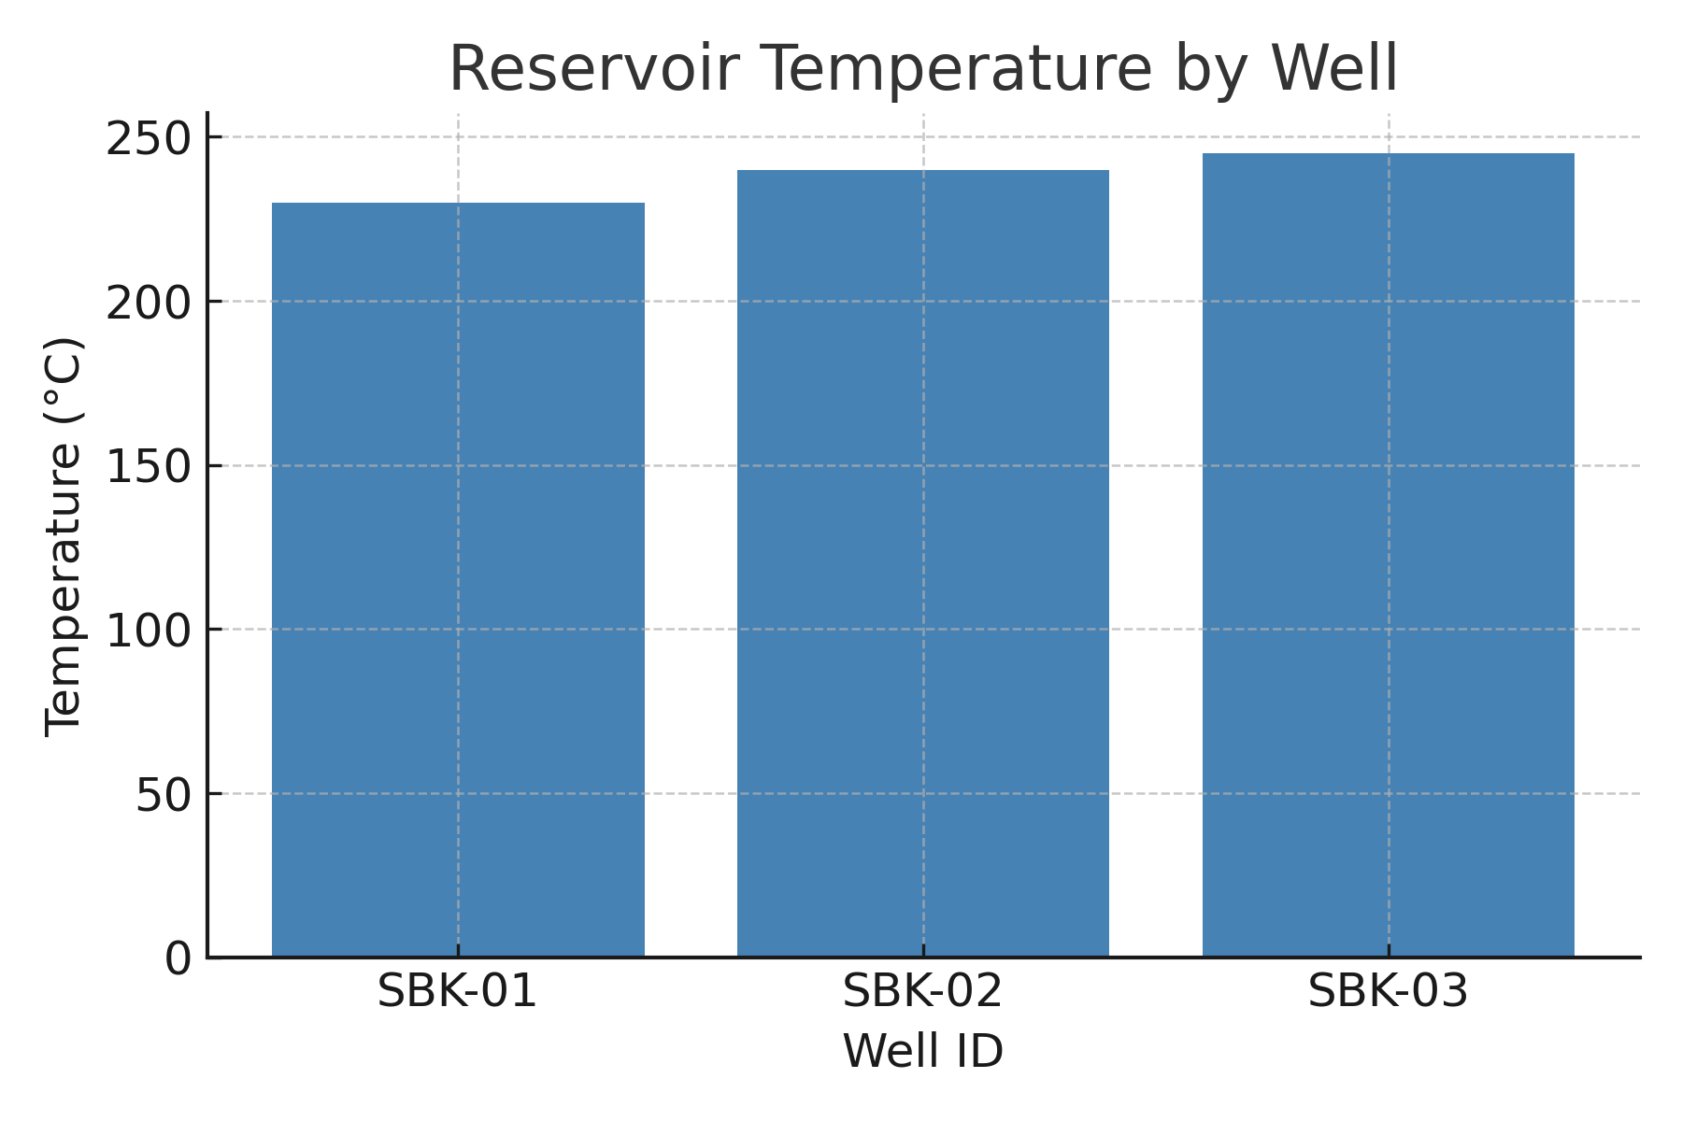
Figure 1. Reservoir temperature by well in Sibayak Field.

Production Sustainability and Decline Analysis
A production decline curve analysis (DCA) reveals that without reinjection, the reservoir pressure decreases by ~5% annually, leading to a capacity reduction of 10–15% within 10 years. Reinjection of spent brine is projected to reduce the decline rate to ~2% annually, extending the reservoir lifetime significantly.
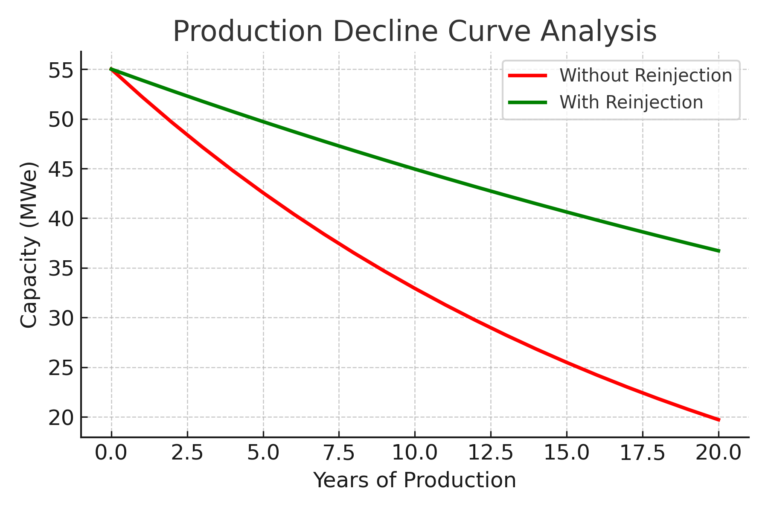
Figure 2. Production decline curve with and without reinjection in Sibayak geothermal reservoir.

Life Cycle Assessment (LCA)
A comparative LCA of geothermal vs. coal and natural gas shows that geothermal has the lowest CO₂ equivalent emissions (90 g CO₂/kWh) compared to coal (1,000 g CO₂/kWh) and natural gas (450 g CO₂/kWh).
Table 2. LCA comparison of power generation technologies
Technology | CO₂ eq (g/kWh) | SO₂ eq (g/kWh) | NOx eq (g/kWh) | Land Use (m²/MWh)
Geothermal | 90 | 0.15 | 0.20 | 2.5
Coal | 1000 | 5.50 | 4.20 | 6.8
Natural Gas | 450 | 2.30 | 1.90 | 4.2
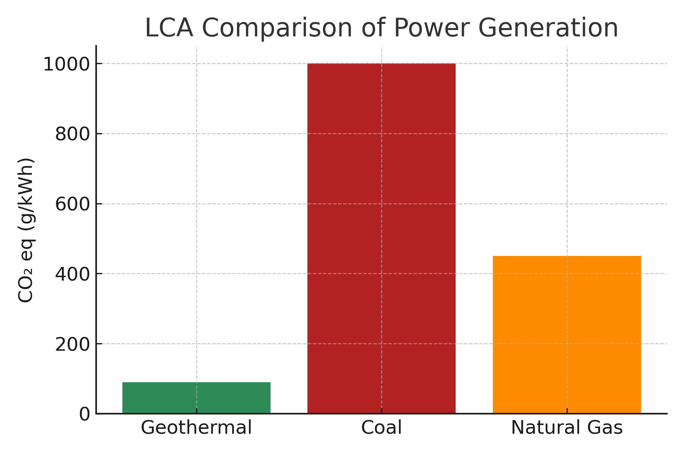
Figure 3. Life Cycle Assessment (LCA) comparison of geothermal, coal, and natural gas power generation systems.

Discussion
The findings confirm that geothermal development in Sibayak is not only technically feasible but also environmentally superior compared to fossil fuels. The high enthalpy values and favorable temperature-pressure profiles suggest long-term sustainability with proper reinjection management. The LCA results emphasize geothermal’s role in Indonesia’s energy transition strategy, reducing GHG emissions significantly. Moreover, the environmental footprint (land use, SO₂, and NOx emissions) is minimal compared to conventional energy systems.

Conclusion
This study demonstrates that the Sibayak geothermal field in North Sumatra possesses substantial potential for sustainable electricity generation. Reservoir measurements indicate favorable temperature and pressure conditions, while decline curve analysis highlights the crucial role of reinjection in maintaining long-term production capacity. Furthermore, the Life Cycle Assessment (LCA) confirms that geothermal energy has a significantly lower environmental footprint compared to coal and natural gas, particularly in terms of CO₂ emissions and land use.
Overall, the integration of reservoir characterization, production sustainability analysis, and environmental assessment provides strong evidence that geothermal development in Sibayak can support Indonesia’s transition toward a cleaner and more resilient energy future.

References
[1] N. A. Pambudi and D. K. Ulfa, “The geothermal energy landscape in Indonesia: A comprehensive 2023 update on power generation, policies, risks, phase and the role of education,” Renew. Sustain. Energy Rev., vol. 189, p. 114008, Jan. 2024, doi: 10.1016/j.rser.2023.114008.
[2] L. P. Siringoringo, B. Sapiie, A. Rudyawan, and I. G. B. E. Sucipta, “Origin of high heat flow in the back-arc basins of Sumatra: An opportunity for geothermal energy development,” Energy Geosci., vol. 5, no. 3, p. 100289, July 2024, doi: 10.1016/j.engeos.2024.100289.
[3] Stanford, “49th Workshop on Geothermal Reservoir Engineering 2024,” Curran Associates, Inc. 57 Morehouse Lane Red Hook, NY, p. 3. [Online]. Available: pangea.stanford.edu/researchgroups/geothermal
[4] R. L. Sianturi and W. S. Nababan, “Hybrid Energy (Thermoelectric Generator-Archimedes Screw Turbine) Study and Experiment as a Green Energy Generator Based on the Internet of Things (IoT),” J. Mech. Eng. Manuf. Mater. ENERGY, vol. 8, no. 2, pp. 147–156, 2024.
[5] M. Qarinur, E. Silitonga, S. Alvan, S. Ogata, N. Kinoshita, and H. Yasuhara, “Comprehensive Geometric Modeling of the Sibayak Geothermal Field,” presented at the Journal of Physics: Conference Series, IOP Publishing, 2024, p. 012007.
[6] M. Kadri et al., “Integrated geophysical methods used to explore geothermal potential areas in Siogung-Ogung, North Sumatra, Indonesia,” 2023.
[7] S. Nur, B. Burton, N. Aida, and M. F. Ikhwali, “Determining optimal incentives for geothermal projects procured within PPP framework under the tariff constraints,” Renew. Energy Focus, vol. 45, pp. 21–39, June 2023, doi: 10.1016/j.ref.2023.02.006.
[8] E. Firanda et al., “Updating Numerical Simulation Model of Sibayak Field, Indonesia”.
[9] M. Qarinur, E. Silitonga, S. Alvan, S. Ogata, N. Kinoshita, and H. Yasuhara, “Comprehensive Geometric Modeling of the Sibayak Geothermal Field,” presented at the Journal of Physics: Conference Series, IOP Publishing, 2024, p. 012007.
[10] P. Dobson, A. R. Pratama, and B. Hamilton, “Technical Geothermal Roadmap for Indonesia,” 2025.
[11] M. Kadri et al., “Integrated geophysical methods used to explore geothermal potential areas in Siogung-Ogung, North Sumatra, Indonesia,” 2023.
[12] A. Jahanbani Ghahfarokhi, “Applications of Data-Driven Techniques in Reservoir Simulation and Management,” in Artificial Intelligent Approaches in Petroleum Geosciences, Springer, 2024, pp. 1–74.

